Useful Information and Links from the Local Authority

SEND Local Offer
Every local authority has a SEND Local Offer. The purpose of the local offer is to enable parents, carers, children and young people with special educational needs or disabilities to see clearly, from a single and regularly updated source, the services available to local families and how to access them. The offer covers services from birth to 25, across education, health and social care.
Kingston and Richmond children's services are provided by Achieving for Children. The SEND Local Offer sits within their AfCinfo website or you can use this direct link Local Offer website for Kingston and Richmond

SEND Local Offer leaflets
SEND Local Offer leaflet (pdf)
Support for children and young people with special educational needs or disabilities (SEND) (pdf)
If you don't live in Kingston or Richmond, your home local authority will also have a SEND Local Offer.
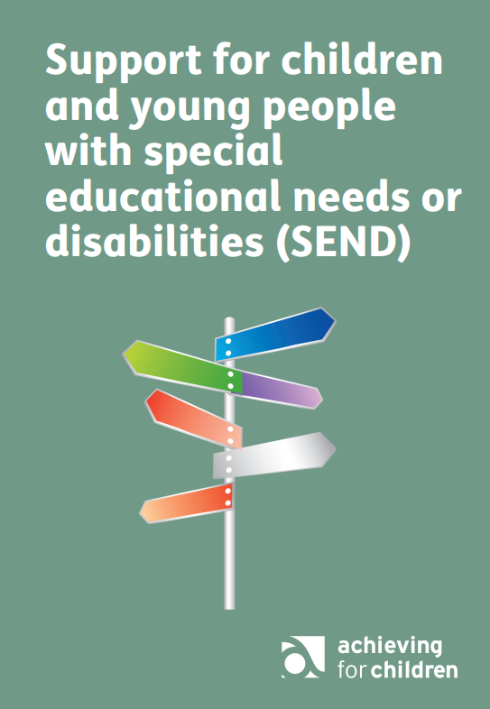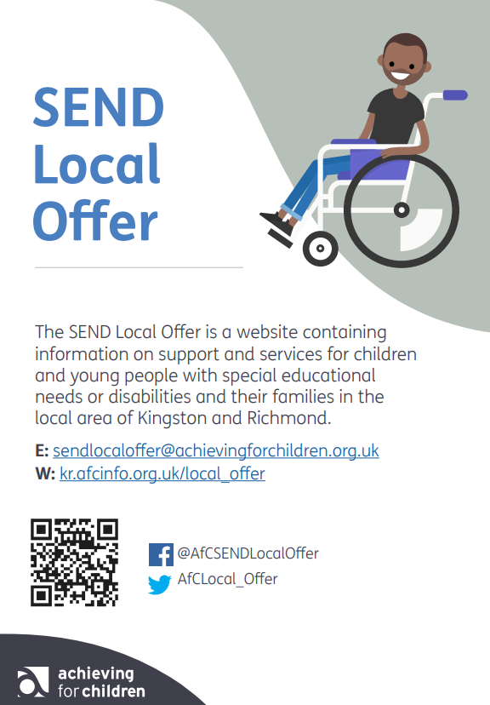

Special Educational Needs and Disabilities (SEND) Parent and Carer Engagement Team
The role of this team in Kingston and Richmond is to ensure that parents and carers of children and young people with Special Educational Needs and Disabilities are fully engaged with the services provided by Achieving for Children.
SEND Parent Engagement Team

Special Educational Needs and Disability Register
All local authorities must have a record or register of children with Special Educational Needs and / or Disabilities (SEND) in their area. If you live in either Kingston or Richmond, we encourage anyone whose family includes a child or young person who has a special educational need or disability to register. Young people over 13 years can register in their own right.
Everyone on the register will benefit from:
- Information about support, services, activities and events
- Information aimed at young people with disabilities
- Opportunities to have your say about the services that are important to you
When you register you have the option to ask for a Disability Awareness Card.
Special Educational Needs and Disability Register on Local Offer
Special Educational Needs and Disability Register leaflet (pdf)
Parent Carer Forums
Parent Carer Forums (PCFs) are independent groups run by parents for parents or carers of children/young people (aged 0 to 25 years) who have any form of special educational need or disability.
They receive funding from the Department for Education and their purpose is to ensure that the voices of parents, children and young people are heard in the planning and implementation of SEND services.
There is a parent carer forum for Richmond and one for Kingston. Again, other areas may have their own PCF.

SEND Information, Advice and Support (SENDIASS)
The Information, Advice and Support Service (SENDIASS) in Kingston and Richmond offers advice and support across a wide range of subjects. This may include help with personal budgets and how to use the Local Offer plus information about:
- local support networks
- education, health and social care services
- your rights in education, health and social care
- mediation and dispute resolution
The service is a free, confidential and impartial. It is for children and young people up to the age of 25yrs who have special educational needs or disabilities, and their parents or carers.

Contact SENDIASS
We're based at The Croft Centre, Windham Road, Twickenham TW9 2HP and at The Moor Lane Centre, Moor Lane, Chessington KT9 2AA.
Freephone number: 0808 164 5527
Email: info@RKsendiass.co.uk
Website: rksendiass.co.uk
For more information about what support and advice is available from Richmond please visit their local offer on www.richmond.gov.uk/send
Kids, a local voluntary sector organisation, delivers the Parent Partnership Service and provides free, impartial, confidential, advice, support and options around educational issues for parent/carers who have children with special educational needs or disabilities. Please visit their website by following the link below:


