Orleans Primary School Nursery Admissions

THE SCHOOL OFFICE ACCEPTS ADMISSION FORMS FROM 1st JANUARY 2023

PLEASE RETURN FORM WITH BIRTH CERTIFICATE AND PROOF OF ADDRESS

Childs Surname ……………………………………………………………………………………………………..

Childs Forename/s……………………………………………………………………………………………….…

Childs DOB:…………………………………………………………………………………………………………..….

Childs Gender…(M or F)………………………………………………………………………………………..

Home Address:………………………………………………………………………………………………………….

………………………………………………………………………………………………………………………………………….

Email : ……………………………………………………………………………………………………………………….
Parent name : ……………………………………………………………………………………………….………..
Mobile : …………………………………………………………………………………………………………….……....

Please list siblings if applicable and current school attending:

Sibling 1……………………………………………………School :………………………………………………
Sibling 2……………………………………………………School :………………………………………………
Sibling 3……………………………………………………School :………………………………………………

Please advise on whether you would prefer a morning or afternoon placement.
(Please note this does not guarentee you a place but will be taken into account when assigning children to classes based on sibling link and distance).

AM - 8.45 – 11.45

PM - 12.30 – 3.30

When can my child start school?
You can calculate the start year based on your child’s date of birth below:
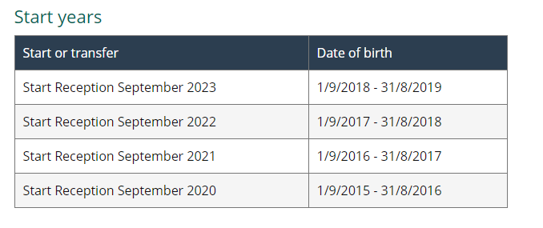
For more information regarding nursery and key dates please visit:

https://kr.afcinfo.org.uk/pages/community-information/information-and-advice/where-to-apply-for-childcare/nursery-and-early-education-providers/school-nursery-classes-and-maintained-nursery-schools

