Handwriting
Guidance

Orleans Primary
School
2011

Written by

C Salisbury
(Literacy Co-ordinator)

Handwriting at Orleans Primary

Magic c letters

a c d g o q

Start like a curly c
Diver letters

b h k m n p r

Down, up and over

Straight letters

i j l t f

Straight down
Zigzag letters

v w x z

+

Curvy letters

e s u y

Stories for Formation

Magic C Letters:
c – curly c, sit the bottom on the line.
o – curly c first, join it up.
a – curly c first, join it up, down with a flick.
d – curly c first, join it uo, go up up tall, down with a flick.
g – curly c first, join it up, down with a monkey tail.
q – curly c first, join it up, straight down with a tick.

Diver Letters:
r – start in the middle, dive down the stick, swim up the stick and over a little.
n – start in the middle, dive down the stick, swim up the stick and over all the way with a flick.
m – start in the middle, dive down the stick, swim up the stick, over and over again all the way with a flick.
h – start at the top, dive down deeper, swim up and over all the way with a flick.
b – start at the top, dive down, bounce back up and around.
k – start at the top, dive down, swim up a little to do the loop, down to do the leg with a flick (k is like a leg kicking a football).
p – start in the middle, dive down with a straight tail, back up, around to do the head.

Straight Letters
i – start in the middle, straight down with a flick and a dot on the top.
l – start at the top, straight down with a flick.
f – start near the top, curl over, straight down deep, curl the other way, arms across (f is tall and it has a tail that goes under the line).
j – start in the middle, straight down with a monkey tail, dot at the top.
t – start near the top, straight down with a big flick, arms out.

Zigzag letters
v – start in the middle, zig down, zag back up.
w – start in the middle, zig down, zag back up, zig down again, zag back up again
x – start in the middle, zig down and across, zag up and across.
z – start in the middle, zig straight along, zag down and across, zig straight along again.

Curvy letters
e – start in the middle, curve over, curve under.
u – start in the middle, down, curve on the line, back up, down with a flick.
y – start in the middle, curve on the line, back up, down with a monkey tail.
s – start in the middle, curve (little curly c in the air), curve the other way.

Note: the first part of many of the letter stories tells the children where to start the letter in relation to the lines. When teaching for the first time without lines, you may want to leave this part out and just focus on the formation.

Extra tips:
c - remember that the pencil always goes back first for curly c to make sure it is the right way round. If c was a caterpillar it would be looking forward, not back like this:
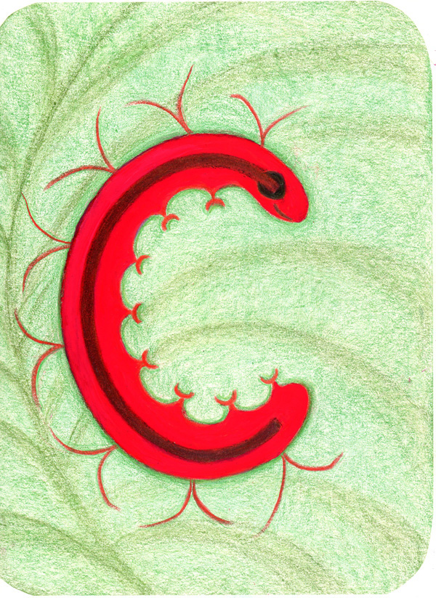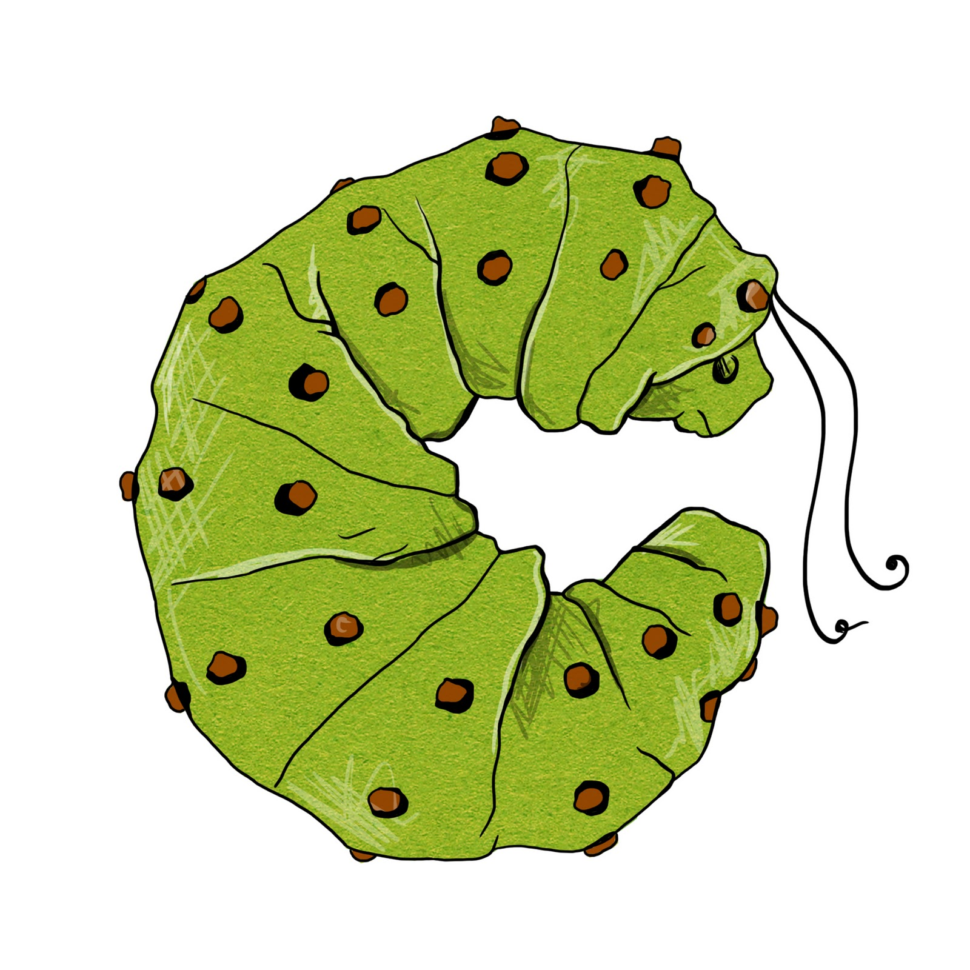
Sometimes visualising the caterpillar can help children ensure their c is the right way round.

Writing on the line – what happens to letters if they’re not on the line? They get dizzy up in the air so we have to make their ‘bottoms’ (hee hee – rude word!) sit on the line.

Remembering the stick on r, n and m – tell the children that r, n and m if they don’t have their friend ‘stick’ they get lonely! They must remember to draw their friend stick first! ‘u’ also gets lonely without a stick but his stick comes last.

a, d, h, i, j, k, l, m, n should all be written with a flick from the beginning to prepare the children for joining.

Getting b and d the right way round:
- looking at your fists with the thumbs up, your left hand makes a b and your right hand makes a d.
E.g. 
- b is bouncy like a bouncy ball and d starts with a curly c. If you remember that, they will always be the right way round.
- the word bed. When bed is written correctly someone can sleep on it like this: 
but if b and d are the wrong way round, someone can’t sleep on it because the sticks are in the way.

Sitting p on the line – small p sits with his chin on the line and the straight tail going underneath. Capital ‘P’ stands up on the line because it’s important.

y, j and g have monkey tails that hang below the branch, e.g. 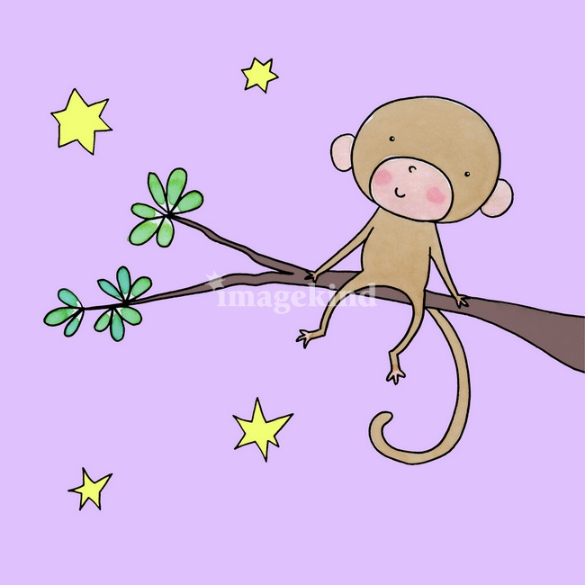

Dotting i – tell the children that we are not playing football so we don’t need footballs on top of our ‘i’ s! Just a dot please! When you right ‘i’, say, ‘are we playing football?’ Hopefully the children will respond with ‘no, we just need a dot!’

Making sure v and w aren’t curved - remember that v and w have pointy bottoms (tee hee – rude word again), not curvy ones!

Capitals – Remember all capital letters are BIG and fill the whole line.

Frog jump capitals
F – Straight down, frog jump, little line out, jump down, little line out
E - Straight down, frog jump, little line out, jump down, little line out,
jump down little line out
D – Straight down, frog jump, big curve down
P – Straight down, frog jump, little curve
B – Straight down, frog jump, little curve, little curve
R – Straight down, frog jump, little curve, kick out
N – Straight down, frog jump, Slide down, go up
M - Straight down, frog jump, Slide down, slide up, go down
H – Straight down, frog jump, straight line down, frog jump, go across
K – Straight down, frog jump, slide in, kick out
Y – Slide down, frog jump and slide in.
A – Slide down, frog jump up, slide down, frog jump, go across
I – Straight line down, jump up and, slide across, jump down, slide across
T – Straight line down, jump up, go across
J – Straight line down, curve on the line, jump up, go across

Straight down capitals
L – Straight down, little line out
U – Straight down, curve on the line, go up

Zigzag capitals
V – zig down, zag back up
W – zig down, zag back up, zig down again, zag back up again
X – zig down and across, zag up and across.
Z - zig straight along, zag down and across, zig straight along again.

Curvy capitals
C – Big curve,
O- Big curve, join it up.
Q – Big curve, join it up, frog jump, little line
G – Big curve, go up, line across
S – Smaller curve, curve the other way

